Partnership for Aflatoxin Control in Africa

Secretariat Strategic Plan Refinement
Executive Summary

Context
The Partnership for Aflatoxin Control in Africa (PACA) was established in 2011 as a community-based organization, co-located with the African Union Commission (AUC) with the mission to support agricultural development, safeguard consumer health, and facilitate trade by catalyzing, coordinating and increasing effective aflatoxin control along agricultural value chains in Africa. In the PACA Strategy 2013-2022, the PACA Secretariat and Community Members identified a comprehensive set of Strategic Thematic Areas (STAs) and associated Key Result Areas (KRAs) that capture all the activities that the PACA Community should look to achieve to realize its vision of an Africa free from the harmful effects of aflatoxin.
Building upon this work, the PACA Secretariat engaged Monitor Deloitte from May to August 2014 to refine this strategy to distinguish the core activities that the Secretariat should own versus those that are owned by the larger PACA Community. The purpose of this strategy refinement engagement was also to identify the activities for which the Secretariat should not be responsible for and should empower and support the PACA Community at large to achieve. The recommendations presented here affirm the direction developed by the PACA Steering Committee and a number of key stakeholders, but offer a new, more targeted focus.
This document provides an executive summary of Strategic Plan Refinement findings for the PACA Secretariat. Please refer to the accompanying PowerPoint deck for the full details on the Strategic Plan Refinement
The recommendations including in the PACA Secretariat’s Strategic Plan Refinement are grouped into the following four areas defining the Secretariat’s:
- Mission
- Roles
- Activities
- Organizational structure, capabilities, and resources

Each area will be further detailed in subsequent sections.

1. Mission
The Secretariat should refine its mission to improve the effectiveness and efficiency of governments to tackle the aflatoxin challenge in Africa. This mission will require the Secretariat to forge strong partnerships and work jointly with other key stakeholders involved in aflatoxin control (e.g., RECs, private sector actors, NGOs, donors) to comprehensively support governments. Accordingly, the recommendations that follow help the Secretariat achieve this refined mission by directly supporting governments and working with other aflatoxin control stakeholders to enable them to more effectively support and work with governments to tackle the aflatoxin issue.
The Secretariat should focus on governments for two reasons. First, governments play a central role in aflatoxin control. Governments are central to controlling aflatoxin contamination and exposure as they have a wide sphere of influence over other key stakeholders (e.g., consumers, value chain actors, NGOs, private sector companies). As a result, only governments have the ability to change behaviors and set priorities across these stakeholders by enacting and enforcing policies, standards, and regulations, launching capacity support initiatives, and implementing awareness campaigns. However, we found through our primary and secondary research and analysis that despite government’s important role, there were few actors that currently focus on supporting governments to mitigate the harmful effects of aflatoxins. In fact, of the 208 organizations analyzed in the aflatoxin external landscape assessment, only 20 directly support governments. This number is quite low, especially in comparison to, for example, the 122 organizations that are focused on supporting agricultural producers. The PACA Secretariat has an opportunity to fill this gap to improve governments’ effectiveness in mitigating the harmful effects of aflatoxin.
Second, the Secretariat also has a comparative advantage in accessing, supporting, and influencing country governments from its position within the AUC. Across our primary and secondary research, we found that the AUC has unparalleled access to country governments – there are few other stakeholders with the ability to set the agenda with governments that the Secretariat has within the AUC. As stated in one interview, “Because PACA sits under the AU umbrella, they can talk to permanent secretaries and members of Parliament, and they’ll be heard.”
s
Figure 1. Country Steering Committee Organogram
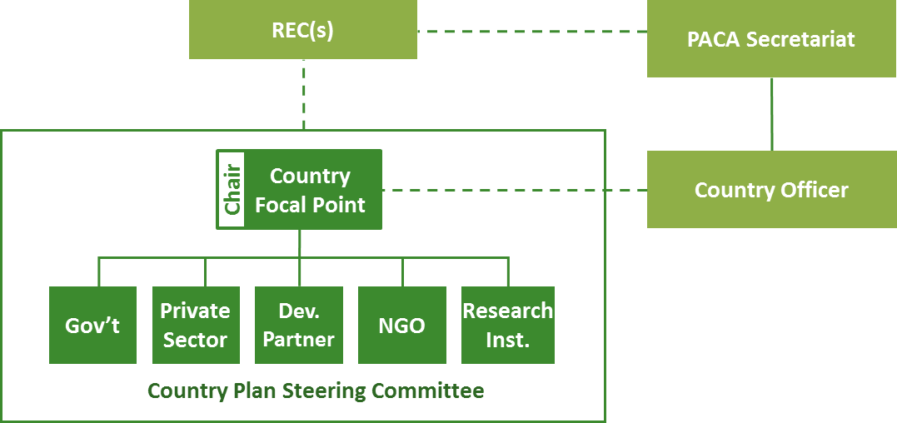
During the initial pilot phase the Secretariat will focus on just five countries and support these country programs for five years. After three years, the Secretariat will review the pilot program progress to assess outcomes and effectiveness, refine the country planning approach to accommodate scaling, and consider additional funding available before scaling beyond these five initial countries.
Through these activities, the Secretariat will enable various stakeholders to build governments’ effectiveness in tackling the aflatoxin issue, while improving the enabling environment to mitigate the harmful effects of aflatoxin.
The PACA Secretariat’s Theory of Change
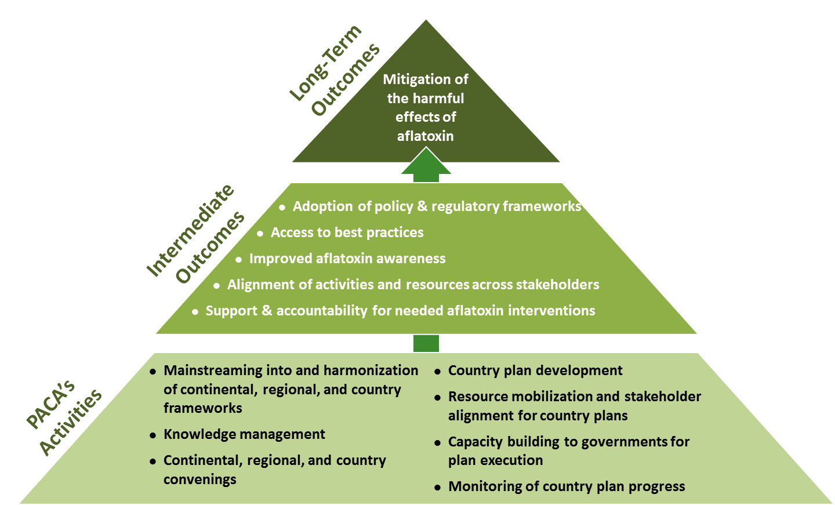

4. Organizational Structure, Capabilities, and Resources
To support these identified roles and activities the Secretariat will need to add the following five new full-time staff. These individual should co-locate with the PACA Secretariat team at the AUC:
- Strategy and Operations Lead
- Policy Advisor
- Knowledge Manager
- Communications and Donor Relations Officer
- Finance and Procurement Officer
With this new structure, the Programme Manager will be able to concentrate his efforts on the executive leadership and overall strategic direction. The Strategy and Operations Lead should be viewed as the Secretariat’s Chief Operating Officer, providing both strategic and operating expertise and managing the country planning process. She or he will directly oversee the Communications and Donor Relations Officer, the two Programme Officers, and the Finance and Procurement Officer.
The Policy and Technical Advisors will work hand-in-hand with each other and serve as the subject matter experts. The two Programme Officers will also work collaboratively together, but each individual will have oversight over 2-3 country pilot programs. The Knowledge Manager will assume all knowledge management activities. The Finance and Procurement officer will be responsible for working within the AUC system to execute financial needs.
Additionally, we recommend that the Secretariat should not establish a third party grantmaking organization. This conclusion is based on evaluation of five criteria:
- Predictability: The grants made by the Secretariat will be predictable, thereby eliminating the need for highly flexible and ad hoc grantmaking that a third party grantmaking organization would be needed to facilitate
- Frequency of Disbursements: The Secretariat’s grants will be one-time disbursements, rather than ongoing, eliminating the need for a sophisticated grants infrastructure to continually manage and monitor disbursements
- Financial implications: Through an internal Secretariat-based grantmaking organization, PACA could realize savings of 10-30% of the total disbursement amount in overhead
- AUC Process Alignment: After engaging the AUC finance team, it was concluded that the Secretariat’s costs can be supported by the existing AUC-procurement system without affecting the implementation timeline for PACA activities
- Finance & Procurement Officer Expertise: An officer with FM and procurement expertise would be able to expedite AUC processes and support the Secretariat to better navigate the AUC system. This position is essential for the Secretariat to function smoothly without a third party grantmaking organization. This position could be shared within DREA.
Overall, the revised strategy and operational plan will require a budget of $11M between FY ‘15 through FY ‘17. With funds available as of August 2014, the Secretariat will face a budget deficit, likely in FY ’16. The Secretariat will need to fundraise an additional $2.6 million in FY ‘16 and $4.9 million in FY ’17.

