Nixtamalization Process and Nutritional Value of Maize (Zea mays L.) Tortillas
Review
Francisco Domingos Sacama
fsacama@ucm.ac.mz
Catholic University of Mozambique

Abstract
The human nutrition should be made based foods that provide nutrients such as carbohydrates, lipids, proteins, vitamins and minerals. The nutrients can be found in fruits, cereals, vegetables, meats and an oil seed, corn is a cereal that is part of the diet of the population consists of 70 – 75 % starch, 4 - 5 % lipid and 10 % protein, and other compounds. The nixtamalization is a alkaline corn processing based on calcium hydroxyl (lime) which improve the availability of the nutrients contained therein, since the alkali treatment the corn is subjected allows the removal of the pericarp, composed of cellulose (molecule insoluble in water), thus by improving soluble fibre in the product 0.9 % in corn to 1.3 % corn dough and 1.7 % in the tortilla. The unit operations and processing materials are accessible because nixtamalization were known since antiquity of the Mexican people.
Keywords: Corn, Fibre, nixtamalization, Unit Operations

- Introduction
Food diet with quality and quantity is essential for body nutrition and health life. Good nutrition is the foundation of successful and productive families, communities and societies. Food provide nutrients as carbohydrates, fat, protein, vitamins and minerals, which converted to energy, body protection and grown. In developing countries under nutrition is the main cause of death in children under the age of five and anaemia in pregnant woman (FAO, 2015). Cultural habits of food preparing, lack hygienic environment and poverty of population determine accessibility of good food and opportunity to get knowledge about nutrition, food storage, preservation and processing.
Maize (Zea mays L.) is third cereal most consumed in world after wheat and rice (Figure 1). It is a domesticated grass that originated approximately 7000 years ago in Mexico. Maize was spread across the world after the European discovery of the Americas and grown rate is about 4 tons per hectare (Gwirtz, 2014). In 2013/2014 world maize harvest was 985.5 million of tons and United State, Chine, Brazil and India contributed with 68 % of global production (FAOSTAT, 2014). According, Mozambican statistics 2012-2014, the maize production was 1.177.000 and 1.357.000 tons, respectively. Most percentage was familiar and middle size agricultural producers. This cereal is processed in order to get mill flour to cook their meals as porridge, mass and bread, (Aldrich, 1975). The objective of this study is provide tortillas nixtamalization method and unit operations equipment in order to be adopt as new processing technical in Mozambican food cultural and provider information for future research and development science.
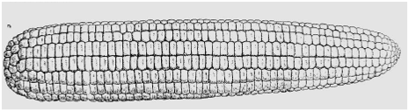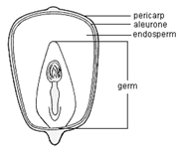
Figure 1. Structure of Ear of Corn and kernel composition. Source: Gene, 2008
- Maize composition and Nutrition value
The maize grains present average density 721 kg/m³ and humidity between 7.5 -23.1 % to storage, (Bakker-Arkema, 1999) and their kernel is composed of endosperm up 83%, germ11%, pericarp5%, and tip cap 1%. The endosperm is primarily structure contain starch composed with 27 % of amylase, linear molecule with 1000 unit of glucose and 73 % of amyl pectin, branched molecule with 40000 unity or more of glucose (Figure 2 e 3). In germ contain 78 % of minerals, phosphor, potassium salt and fitic acid are more abundant, maize oil present low concentration of saturated fat. Quality protein maize (QPM) have got high concentration of digestive protein relatively normal maize, with 55 % more of tryptophan, 30 % more of lysine and 38 % less of leucine.

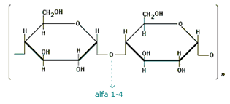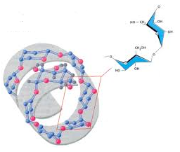
Figure 2. Chemical structure of amylase and their conformation.
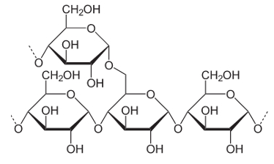
Figure 3. Chemical structure of amyl pectin.

The diet fibre is highly desirable and an important component in food and exerts various physiological functions related to health. The alkaline cooking and dip causes the dissolution and filling the pericarp layer, this causes the cell walls and diet fibre components of this part of the grain becomes fragile, facilitating their removal and reduces the insoluble diet fibre content (Figure 4). Moreover this process is the increase of 0.9 % soluble fibre in corn to 1.3 % and 1.7 % in tortilla.

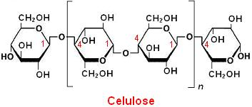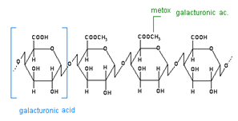
Figure 4. Insoluble and soluble fibres (cellulose and pectin acid)
The nixtamalization causes the breakdown and dissolution of the union structure of endosperm cells (average layer) and cell walls. Most germs maintain in grain during the process, which does not affect the quality of the protein in the dough product. Furthermore, the semi permeable membrane around the grain remains intact during the treatment, which minimizes the lost nutrients by leaching.

3. Nixtamalization and Maize Tortilla Processing
Maize grain processing is done by nixtamalization, dry and wet milling, which transform maize into products for human consumption as food and drinks. Corn flour (Gwirtz, 2014), is obtained by milling the corn kernels through hammer mill, ball or roller operation and the wet grinding allows the separation of the components, it are not produced on a small scale commercially or in the home.
The nixtamalization process of the corn grain is the addition of 4.6-7 l of water and 24.5-56 g of calcium hydroxide (lime) to 3.5 kg of corn, the mixture is cooked at 92 ° C, 50 to 90 minutes and let them in steeping for 14 to18 hours, after it is washed 2 to 4 times with water and remove the pericarp, then the nixtamal is ground, thereby forming a paste with 30 g which is mould in the form of disk 10 cm x 0.2 cm and bakes in the oven at 290 ° C, 30 seconds after turning on the other side after 40 seconds, thereby obtaining the tortilla (Figure 6).

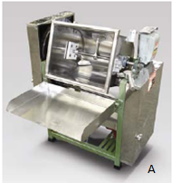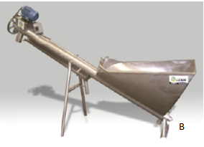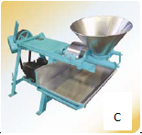
Figure 5. Unit operations Equipments of Nixtamal. A – Blender, B – Cleaner e C – Mill
Source: LENIN, 2009

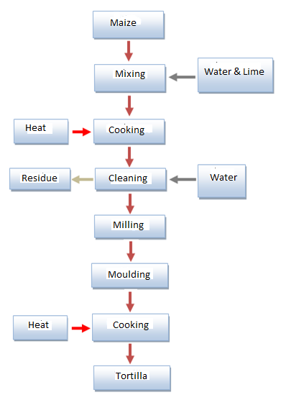
Figure 6. Tortilla processing fluxogram. Source: Rangel-Meza et al, 2004
The equipment for processing tortilla (Figure 5) is characterized according to the particular unit operations in every manufacturing step, these are stainless steel and comprise cooking vessel, mixer and homogenizer, washer nixtamal mill, receiving table dough, baking oven, water tank, and auxiliary boiler.

4. Conclusion
Maize processing upgrade availability of nutritional components contained in kernel, it are basic need for the human body to perform their duties. Mozambique produce corn as principal crop to feed population, and new methodology to follow as nixtamalization allows the reduction of insoluble fibre, so the availability of minerals, soluble fibre and protein. The small and media size technical and production is accessible to people in order to make tortillas which contain 1.7 % of diet fibre comparatively traditional maize flours consumed nowadays in country. This process was already used before the advent of modern machines.

Reference

Aldrich, S.R.; Scott, W.O.; Leng, E.R. (1975). Modern corn production. A&L Publications, Champaign, Illinois. p. 378 .
Bakker-Arkema, F. W. e DebBaerdemaeker, J., (1999). CIGR Handbook of Agricultural Engineering. Volume IV, American Society of Agricultural Engineers, USA.
CastilloV.K.C., Ochoa M.L.A., Figueroa C.J.D., Delgado L.E., Gallegos I.J.A., Morales C.J. (2009). Efecto de la concentración de hidróxido de calcio y tiempo de cocción del grano de maíz (Zea mays L.) nixtamalizado, sobre las características fisicoquímicas y reológicas del nixtamal. Instituto Tecnológico de Durango Vol. 59, no. 4.
Caballero-Briones, F., Iribarren, A., Peña, J. L. (2000). Recent advances on the understanding of the nixtamalization process. Superficies y Vacío 10, 20-24.
Cuevas-Martínez, D., Moreno-Ramos, C., (2010). Nutrition and Texture Evaluation of Maize-White Common Bean Nixtamalized Tortillas. INTERCIÊNCIA,Vol. 35 Nº 11.
Campus-Baypoli, O. N., Rosas-Burgos, E. C., (1999). Physiochemical Changes of Starch During Maize Tortilla Production. Starch/Stärke 51 No. 5: 173–177.
Durán-deBazúa, C, Sánchez-Tovar, S.A., Hernández-Morales, M.R. (2007). Use of Anaerobic-Aerobic Treatment Systems for Maize Processing Installations: Applied Microbiology in Action. FORMATEX.
FAO, (2015). Healthy Harvest. 2 nd Edition, FAO Zimbabwe.
Flores, L. G., Martínez, V. H., Kantún, G. I. K. (2010). Nixtamalización de Maíz: Prácticas Seguras en el Sector Agroindustrial. México.
Gene Tecnology Regulator, (2008). The Biology of Zea mays L. ssp mays. Department of Health and Ageing. Australia.
Guzmán, A. Q., Flores, M. E. J. (2009). Changes on the structure, consistency, physicochemical and viscoelastic properties of corn (Zea mays sp.) under different nixtamalization conditions. Carbohydrate Polymers, 78: 908–916.
Gwirtz, J. A., Garcia-Casal, M. N. (2014). Processing maize flour and corn meal food products New York Academy of Sciences, 1312: 66–75.
Instituto Nacional de Estatistica, (2015). Anuario Estatístico 2014. Instituto Nacional de Estatística de Moçambique, p. 55.
José Salazar-Martínez et al. (2015). Calidad del Nixtamal y su Relación con el Ambiente de Cultivo del Maíz. Revista Fitotécnica de México. Vol. 38 (1): 67 – 73.
Johnson, W. B., et al., (2010). Factors Affecting the Alkaline Cooking Performance of Selected Corn and Sorghum Hybrids. Cereal Chemistry. 87(6):524–531.
Lecuona-Villanueva, A., Betancur-Ancona, D. A., Chel-Guerrero, L. A., Castellanos-Ruelas, A. F., (2012). Protein Fortification of Corn Tortillas: Effects on Physicochemical Characteristics, Nutritional Value and Acceptance. Food and Nutrition Sciences, 3: 1658-1663.
LENIN, M., (2009). Catalogo de Maquinaria y Equipo para Tortillerías y Molinhos. México.
López, O. P., Lara, F. G., Pérez, L. A. B., (2009). La Nixtamalización y el Valor Nutritivo Maiz CIÊNCIAS: 92-93.
Mabilana, H. A., Fontana, D. C., Fonseca, E. L., (2012). Desenvolvimento de modelo agrometeorológico espectral para estimativa de rendimento do milho na Província de Manica-Moçambique1 Rev. Ceres, Viçosa, v. 59, n.3, p. 337-349.
Mejía, D., (2003). Maize: Post-Harvest Operation. AGST/FAO.
Moreno-Castro, L.E., Quintero-Ramos, A., (2015). Nixtamalization Assisted With Ultrasound: Effect on Mass Transfer and Physicochemical Properties of Nixtamal, Masa and Tortilla. Revista Mexicana de Ingeniería Química Vol. 14, No. 2 265-279.
Ortega, E. I., Villegas, E., Surinderk K. (1986). A Comparative Study of Protein Changes in Normal and Quality Protein Maize During Tortilla Making. Cereal Chemistry, 63(5):446-451.
Rangel-Meza, E. et al., (2004). Nixtamalización, Elaboración y Calidad de Tortilla de Maices de Ecatlan, Pueblo, México. Agrociência 38:53-61.
Rodríguez, M. E. et al., (1996). Influence of the Strutural Changes During Alkaline Cooking on the Thermal, Rheological, and Dielectric Properties of Corn Tortillas. Cereal Chemistry, 73(5):593 – 600.
Rooney L. W., Suhendro E. L., (1999). Perspectives on Nixtamalization (Alkaline Cooking) of Maize for Tortillas and Snacks. American Association of Cereal Chemists Vol. 44, no. 7.
Rosentrater, K.A., Richard, T.L., (2003). Resources Economic simulation modeling of reprocessing alternatives for corn masa by products. Conservation and Recycling 39: 341-/367.
Rosentrater, K.A. (2006). A review of corn masa processing residues: Generation, properties, and potential utilization. Waste Management, 26: 284–292.
Rojas-Molina, I., Gutierrez-Cortez, E., Palacios-Fonseca, A., (2007). Study of Structural and Thermal Changes in Endosperm of Quality Protein Maize During Traditional Nixtamalization Process. Cereal Chemistry, 84(4):304–312.
Ruiz-Gutiérrez, M.G., et al., (2010). Changes in mass transfer, thermal and physicochemical properties during nixtamalization of corn with and without agitation at different temperatures. Journal of Food Engineering 98 76–83.
Vega-Rojas, L. J., Contreras-Padilla, M., (2016). The Effect of Maize Grain Size on the Physicochemical Properties of Isolated Starch, Crude Maize Flour and Nixtamalized Maize Flours. Agricultural Sciences, 7, 114-125.
Walstra, P., (2003). Physical Chemistry of Foods. Marcel Dekker, NY.

