Communiqué on the Tanzania Stakeholders Meeting for Reviewing the Aflatoxin Action Plan and Mainstreaming into the TAFSIP
Nelson-Mandela African Institution of Science and Technology,
Arusha, Tanzania
21 May 2015

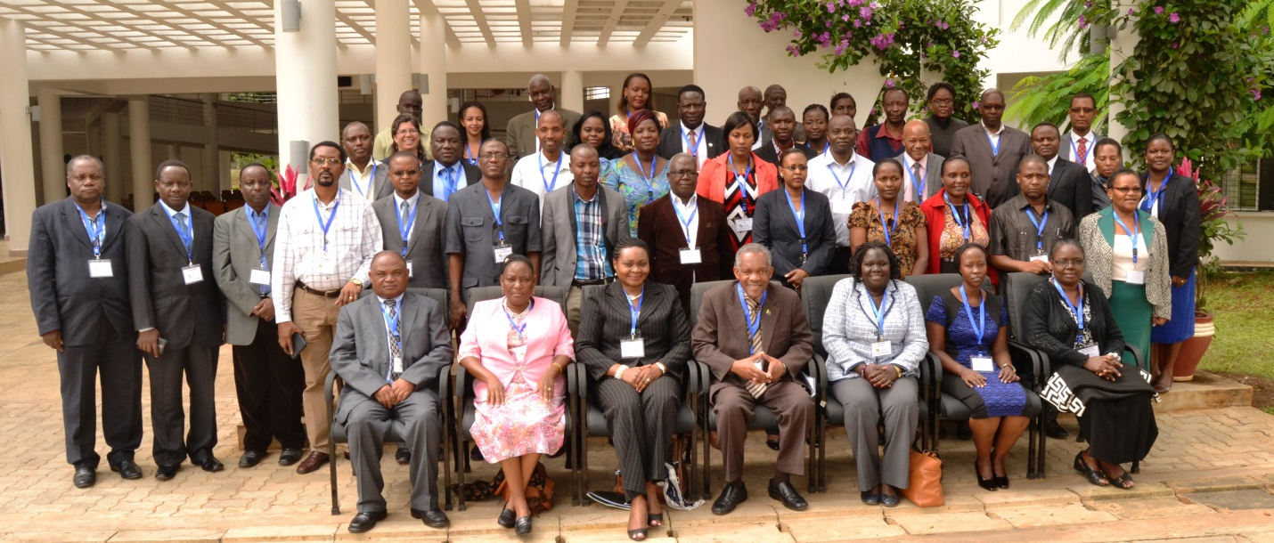
On 20-21 May 2015, approximately fifty stakeholders from agriculture, health, and trade met in Arusha, Tanzania to adopt the Tanzania Aflatoxin Control Action Plan and mainstream it into the Tanzania Agriculture and Food Security Investment Plan (TAFSIP).

Preamble
The African Union Commission (AUC) endorsed the creation of the Partnership for aflatoxin Control in Africa (PACA) at the 7th CAADP Partnership Platform in Yaounde, Cameroon in March 2011. PACA was officially launched by the AUC and endorsed by the Joint Conference for Ministers of Agriculture and Ministers of Trade on 31 October, 2012.
The United Republic of Tanzania, in collaboration with the African Union through the Partnership for Aflatoxin Control in Africa (PACA) and other key partners convened a workshop on “Reviewing the Aflatoxin Action Plan and Mainstreaming into the TAFSIP” from 20-21 May 2015.
The delegates from the Prime Minister’s Office, Prime Minister’s Office Regional Administration and Local Government (Dodoma), Ministry of Agriculture, Food Security and Cooperatives, Ministry of Industry and Trade, Ministry of Health and Social Welfare, Tanzania Food and Drugs Authority, Tanzania Bureau of Standards, Ministry of Education and Vocational Training, Tanzania Mycotoxins Steering Committee, Nelson Mandela – African Institution of Science and Technology (NM-AIST), Sokoine University of Agriculture, Makerere University, Africa Union Commission, PACA Secretariat, Meridian Institute reviewed and, with minor amendments, validated the Tanzania Aflatoxin Control Action Plan and draft addendum to the TAFSIP.
The workshop benefited from the Country-led Situation Analysis and Action Plan (C-SAAP) prepared by national consultants, Dr. Martin Kimanya and Dr. Emmanuel Mpolya from NM-AIST and Prof. Bendantunguka Tiisekwa from Sokoine University of Agriculture (SUA), based on sampling and analysis of key crops of concern and consultations with a range of stakeholders. Through this C-SAAP, the consultants updated the status of aflatoxin prevalence for maize and groundnuts, assessed aflatoxin contamination in rice, collected information on food safety systems in place for mitigation of the problem, and formulated recommendations as well as specific investment options for aflatoxin mitigation and strengthened food safety systems.

Recommendations
Attendees of the Tanzania Stakeholders Meeting for Reviewing the Aflatoxin Action Plan and Mainstreaming into the TAFSIP reviewed and adopted the situation analysis and action plan with minor changes. Attendees recommended additions and modifications to enhance the Tanzania Aflatoxin Control Action Plan in three areas: 1) Aflatoxins Risk Management, 2) Aflatoxins Risk Assessment, and 3) Aflatoxins Risk Communication, (see attached addendum- Table 4: Strategic action plan for mitigation of the aflatoxin problem in Tanzania).

Call to Action
In the light of the real threats that aflatoxin poses to the region in terms of food security, trade, health and overall livelihoods, and given that aflatoxin begins in the fields and in crop value chains, stakeholders recommended that the action plan be mainstreamed into the Agriculture Sector Development Plan (ASDP II) through which TAFSIP is implemented. Furthermore, the meeting observed that all the actions being proposed are implementable through TAFSIP given the fact that all relevant Ministries (including Ministry of Health and Social Welfare) have been included among the lead ministries for TAFSIP implementation.
Therefore, the aflatoxin mitigation action plan will be mainstreamed in the ASDP II, appended in the TAFSIP and implemented through the seven goals of the TAFSIP.
The following steps were agreed on:
- PACA to submit a synopsis of the meeting with a covering letter from Africa Union Commission to the Ministry of Agriculture, Food Security and Cooperatives requesting to make a presentation on the Aflatoxin Mitigation Action Plan at the Agriculture Consultative Meeting. Thereafter the priority actions will be streamlined for implementation.
Once the Aflatoxin Action Plan has been mainstreamed into the ASDP II and appended for implementation in the TAFSIP, The United Republic of Tanzania and African Union Commission through the PACA will deploy deliberate efforts for mobilizing resources through a business meeting to be held on 6 August 2015 or as decided during the Agriculture Sector Consultative Group (ASCG) meeting. In so doing, the following actions will be taken:

  - PACA will share the action plan with Donors (national, regional and international) to get input and to sensitize them on the business meeting envisioned.
  - PACA will work with the United Republic of Tanzania (relevant stakeholders) to host a business meeting in order to mobilize resources for the aflatoxin mitigation action plan
  - When agreement on funding has been reached, the MAFC will ensure incorporation of the fundamental aspects of the action plan into the TAFSIP document
Other Follow up actions:
- IITA and NM-AIST were invited to attend the ASCG meeting with the views to share more insights on the Aflatoxin Mitigation Action Plan

- The Ministry of Agriculture Food Security and Cooperatives will take lead in ensuring that implementation progress is tracked through the annual joint reviews. Additionally, PACA will work closely with all lead implementers of the action plan to hold an annual “read out“meeting in order to monitor progress of implementation of the action plan.

Officials at the Prime Minister’s Office of Business Coordination, Ministry of Agriculture, Food Security and Cooperatives, Ministry of Industry, Trade and Markets, Ministry of Health and Social Welfare, Tanzania Food and Drugs Authority, Tanzania Bureau of Standards, farmers organisations, district level authorities, and the International Institute for Tropical Agriculture.

