Communiqué on the Uganda Stakeholders Meeting for Reviewing the Aflatoxin Action Plan and Mainstreaming into the DSIP

Golf Coarse Hotel, Kampala, Uganda
26 June 2015
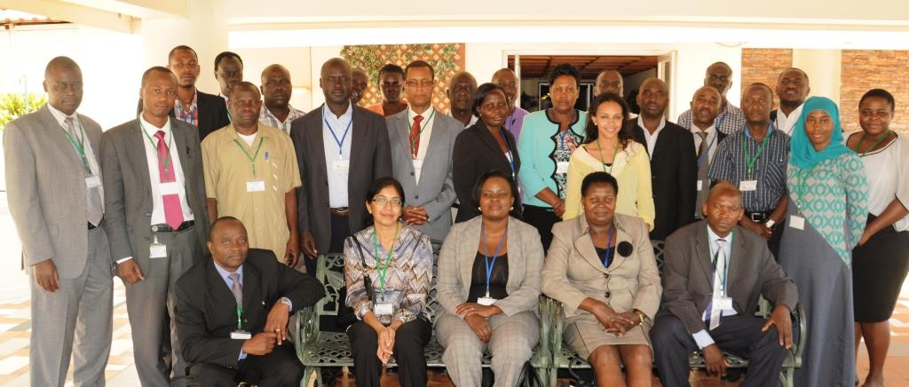
On 25-26 June 2015, approximately forty stakeholders from agriculture, health, and trade met in Kampala, Uganda to adopt the Uganda Aflatoxin Control Action Plan and mainstream it into the Uganda Agriculture Sector Strategic Plan (ASSP).

Preamble
The African Union Commission (AUC) endorsed the creation of the Partnership for aflatoxin Control in Africa (PACA) at the 7th CAADP Partnership Platform in Yaounde, Cameroon in March 2011. PACA was officially launched by the AUC and endorsed by the Joint Conference for Ministers of Agriculture and Ministers of Trade on 31 October, 2012. At the 10th CAADP Platform Meeting in 2014, Uganda was selected as one of the pilot countries.
PACA has been supporting a number of activities in Uganda including Country – led situation analysis and economic impact assessment, AfricaAIMS training and action planning. In this regard, the e Republic of Uganda, in collaboration with the African Union through the Partnership for Aflatoxin Control in Africa (PACA) and other key partners convened a workshop on “Reviewing the Aflatoxin Action Plan and Mainstreaming into the DSIP” from 25-26 June 2015.
The attendees from the Ministry of Health, Ministry of Trade Industry and Cooperatives, Ministry of Agriculture Animal Industry and Fisheries (MAAIF), Plan for modernization of Agriculture Secretariat - MAAIF, National Drug Authority, Food and Nutrition Solutions (FONUS), Makerere University, Local District Governments, USAID East African Mission, Chemonics International - Feed the Future, Uganda National Bureau of Standards, Feed Manufacturers Association, Reco Industries Ltd, Uganda Industrial Research Organization, African Union Commission, ,PACA Steering Committee Members , Pan African Agribusiness & Agroindustry Consortium (PanAAC), CONSENT Uganda, and the PACA Secretariat with minor amendments, validated the Uganda Aflatoxin Control Action Plan to be mainstreamed into the Agriculture Sector Strategic Plan (ASSP) of Uganda.
The workshop benefited from the Country-led Situation Analysis and Action Plan (C-SAAP) prepared by national consultants, Prof. Archileo Kaaya, Dr. Abel Atukwase , Dr. Gaston A. Tumuhimbise , Dr. Alex Tatwangire and Mr. Wilson Asiimwe - Makerere University/Ministry of Finance, Planning and Economic Development. Through the C-SAAP, the consultants established the status of aflatoxin prevalence for maize, groundnuts and sorghum, collected information on food safety systems in place for mitigation of the problem, and formulated recommendations as well as specific investment options for aflatoxin mitigation and strengthened food safety systems.

Recommendations
Attendees of the Uganda Stakeholders Meeting for Reviewing the Aflatoxin Action Plan and Mainstreaming into the ASSP reviewed and adopted the situation analysis and action plan with minor changes. Attendees recommended additions and modifications to enhance the Uganda Aflatoxin Control Action Plan in four thematic areas: Effective aflatoxin management in the agricultural value chains, Public awareness and advocacy, Public health management and Policy and legislation, as well as monitoring and evaluation, (see attached action plan).

Call to Action
In the light of the real threats that aflatoxin poses to the region in terms of food security, trade, health and overall livelihoods, and given that aflatoxin begins in the field and continues along the crop value chains, stakeholders recommended that the action plan be mainstreamed into the ASSP being implemented by the Ministry of Agriculture Animal Industry and Fisheries (MAAIF). Furthermore, the meeting observed that the DSIP is in review and will expire on 30 June 2015. In place of the DSIP will be the ASSP. Therefore efforts should be made to submit the action plan to the leadership in MAAIF for consideration to be included in the ASSP.
Therefore, the aflatoxin mitigation action plan will be mainstreamed in the ASSP through the approved action plan.
The following steps were agreed on:
- PACA to submit a synopsis paper of the meeting with a covering letter from Africa Union Commission to Ministry of Agriculture, Animal Industry and Fisheries requesting to make a presentation on the Aflatoxin Mitigation Action Plan to be considered for the inclusion to be streamlined in the ASSP before the DSIP expires on 30 June 2015.
Once the Aflatoxin Action Plan has been mainstreamed into the DSIP /ASSP for implementation, the Republic of Uganda and African Union Commission through the PACA will deploy deliberate efforts for mobilizing resources through a business meeting to be held, on tentative date - 13 August 2015. In so doing, the following actions will be taken:

  - PACA will share the action plan with Donors (national, regional and international) to get input and to sensitize them on the business meeting envisioned.
  - PACA will work with the Republic of Uganda (relevant stakeholders) to host a business meeting in order to mobilize resources for the aflatoxin mitigation action plan
  - , The MAAIF will ensure incorporation of the fundamental aspects of the action plan into the ASSP document
Other Follow up actions:
- Discuss with MAAIF on other concrete steps for mainstreaming the action plan

Ministry of Trade and Tourism, Ministry of Agriculture, Animal Industry and Fisheries (MAAIF), Ministry of Finance and Ministry of Health, Uganda Bureau of Standards and Uganda National Drug Authority, National Agriculture Research Organization (NARO). District levels authorities consulted and from which samples were collected are Mubende, Kamwenge and Masidi in the Western Savannah Grasslands; Iganga, Soroti, Tororo, Amuria in the Kionga Plains; Gulu and Lira in the North Eastern Savannah Grasslands. Africa Union Commission, the PACA secretariat, steering committee, COMESA and PACA contact points for Tanzania and Malawi also contributed to the formulation of the recommendations which will inform the aflatoxin mitigation strategic actions of the action plan.
With clearly packaged information on impact on trade, health and agriculture as well as putting CAADP in the forefront.

