Uganda Roundtable Discussions

on

**Support towards the abatement of the Aflatoxin for the Health, food and nutrition security, and economic stability/growth**

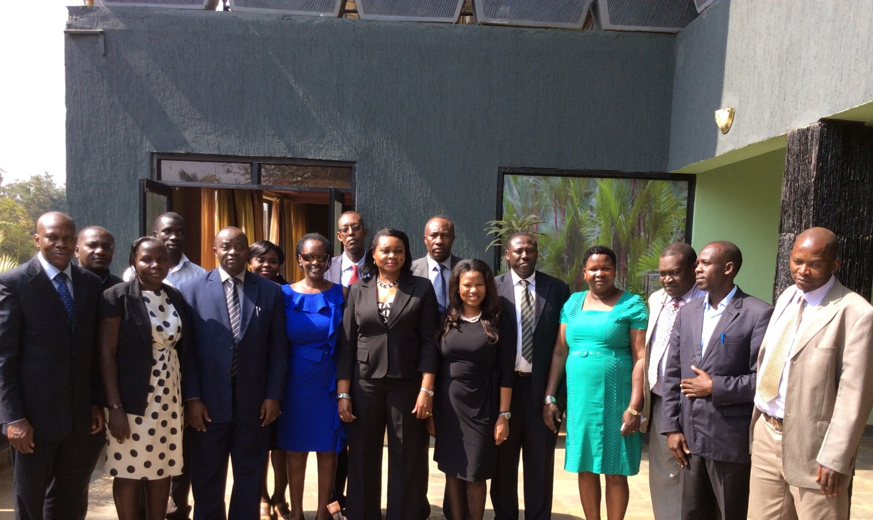

**Venue: Kampala, Uganda: 24-25 July 2014**

**Meeting Outcome Report and Consensus**

**Workshop Discussion Outcomes**

Uganda Government representatives acknowledged that aflatoxins are a vexing challenge to food safety and efforts to increase trade (as a non-tariff barrier). It was noted that aflatoxins are a cross-cutting issue that need to be addressed in the three sectors of health, trade and agriculture. It was also noted that the aflatoxin issue is particularly problematic in countries like Uganda as large populations suffer from diseases that attach the immune system such as HIV/AIDS and Hepatis B. The Commissioner of Trade, Industry and Cooperatives, Uganda noted that aflatoxins have proven to be a major barrier in linking farmers to markets as they prevent commodities/produce from meeting international, regional and local regulations and standards related to agricultural trade and food safety. He further informed delegates that standards for staple foods were elaborated in the EAC aflatoxin strategy that specified limits for total Aflatoxin in the commodities at 10ppb in order the protect the health and safety of the consumers in the region while promoting trade. However, it was synthesized that challenges still remain related to compliance and application of standards in the region.

It was further noted that throughout the globe, tariffs are now waning under the influence of the World Trade Organization (WTO). But, non-tariff barriers continue to pose a big challenge to Uganda’s exports. For example, in markets, where Uganda’s products enjoy preferential treatment, such as the US Africa Growth and Opportunity Act market, entry still remains difficult on grounds of quality, packaging, handling, etc.

The Commissioner welcomed the Roundtable Discussion and noted the multi-stakeholder participation from key Ministries of Trade, Health and Agriculture and Academia and was therefore optimistic that the implementation of aflatoxin strategies in Uganda will go a long way in enhancing trade regionally and internationally.

COMESA representative commended PACA for the work that it has embarked on in the efforts of harmonizing and coordinating aflatoxin mitigation interventions in country. The COMESA SPS Coordinator encouraged delegates to involve the private sector in the efforts to mitigate aflatoxins.

EAC representatives enlightened delegates that they had developed a regional strategy for mitigating aflatoxin and they encouraged other RECs to learn from their lesson.

NEPAD Planning and Coordinating Agency (NPCA) encouraged the Uganda delegates and PACA Secretariat to continue the efforts towards aflatoxin mitigation especially through the review of NAFSIPs to mainstream aflatoxin mitigation strategies, which are in line with the continental vision of sustaining the CAADP momentum.

The AUC congratulated Uganda for having been chosen as a pilot country through the intensive process that was endorsed at the 10th CAADP PP. It was noted that Uganda is the first country to have had roundtable discussions with both their RECs present, NPCA, and AUC represented by PACA Secretariat, Department of Rural Economy and Agriculture, Department of Trade and Industry and the Department of Social Affairs. AUC expressed the need to address aflatoxin mitigation in Uganda in order to speak to the Malabo declarations.

The PACA Technical Officer informed the delegates that African Governments are key to addressing aflatoxin mitigation; yet, little support is given to governments to play this role. He informed that PACA will work closely with governments and provide appropriate support, where possible, to enable them to play the key role of combating aflatoxins in the country. The PACA Program Officer gave an overview of the PACA Country Activities Inception workshop that was held on 10-11 June 2014 in Dar es Salaam, Tanzania. She explained the various steps and methodologies that were agreed upon with pilot country delegates, AUC and RECs for implementing PACA Pilot Country Activities.

**Session Ib**

**Presentation 1:** Prof. Archileo Kaaya gave an overview of aflatoxin prevalence in Uganda which revealed that the aflatoxin issue was rampant in the country. Prof. Kaaya called for the following actions to be taken to continue efforts of mitigating aflatoxins in Uganda:

* Routine Monitoring and surveillance of susceptible crops;
* Enforce standards and regulations;
* Link farmers to better markets;
* Improve the laboratory services; and:
* Establish more accredited labs.

**Presentation 2**: Mrs Agnes Namwase presented on the Development Strategy Investment Plan (DSIP) of Uganda. She presented on, *inter- alia,* the institutional set up of the MAAIF DSIP Implementation which involves relevant sector institutions including both the public and private actors namely:

* Political leadership provided by the President; the Cabinet; Ministers and Parliamentary Sessional Committee on Agriculture
* High level policy oversight and guidance by MAAIF Top Policy Management (TPM), supported by a TPM Technical Committee; and
* Technical leadership and coordination by the agriculture sector working group (ASWG)-private sector, CSOs, DPs

**Presentation 3:** Mrs Kefilwe Moalosi presented on the CAADP Nutrition Initiatives and highlighted the steps that were taken in reviewing NAFSIPs to mainstream nutrition. Mrs. Moalosi noted that the PACA approach for mainstreaming aflatoxins into the NAFSIPs is similar to the steps taken in the CAADP Nutrition Initiatives of NEPAD. The following similarities were drawn on:

* PACA Situation Analysis is similar to the Nutrition Country Papers
* The *PACA Country Activities Inception Workshop* is similar to the *CAADP workshop on the integration of nutrition in National Agricultural and Food Security Investment Plan workshop; and*
* The Aflatoxin Action Plan that will be mainstreamed into the NAFSIPs is similar to the road maps developed for the CAADP Nutrition Initiative

Ms Moalosi also noted that during the CAADP Nutrition Regional Capacity Development workshops, the costing exercise of the nutrition interventions were demonstrated in country nutrition roadmaps. She further said the costing interventions of the aflatoxin national action plans is a similar step that the nutrition initiative conducted in costing nutrition interventions.

**Discussions arising from Presentations:**

* It was noted that the MAAIF DSIP framework is an appropriate framework to mainstream aflatoxin into as it is comprehensive, broad and inclusive. It was also noted that although the DSIP was flexible to enable inter-sectoral collaboration in implementing cross-cutting issues, it was important that the other sector ministries (MOH and Min. of Trade) also mainstream aflatoxin issues in their respective DSIPs;
* It was further noted that as Uganda is Drafting the NDP, the issues aflatoxin in relation to Food Security (Food wholesomeness, Food availability and Food safety) be mainstreamed;
* COMESA reaffirmed its commitments to assisting Uganda in implementing actions for aflatoxin mitigation by offering, where possible, to leverage and pull resources;
* COMESA encouraged delegates to address the aflatoxin issue with the broad continental and regional lens but to act locally by coming up with action plans informed by evidence;
* The PACA Secretariat was encouraged to address agriculture in totality to include livestock issues especially animal feeds and fisheries in the situation analysis. It was however noted that the Uganda experts at the PACA Inception Workshop addressed animal feed indirectly by choosing to study the sorghum, groundnuts and maize value chain in the situation analysis and these crops make up the bulk ingredients in animal feed;
* It was noted that it was necessary for aflatoxin education and awareness to reach down to the farm-gate and household level as it is at this level that aflatoxin is most prevalent;
* Delegates encourage EAC to open up their regional strategy for aflatoxin mitigation development process to involve more stakeholders before the strategy is endorsed; and
* It was interesting to note that the NAFSIP reviews to mainstream nutrition through the nutrition initiative of NEPAD assisted Uganda to mobilize up to US $27 million for nutrition initiatives. It was therefore encouraging to note that the NAFSIP reviews to mainstream aflatoxin mitigation has the potential to mobilize similar funds through the process.

**Meeting Recommendations and Consensus**

Representatives of the Government of The Republic of Uganda, the Academia, AU Commission, the Common Market for Eastern and Southern Africa, the East African Community and the NEPAD Planning and Coordinating Agency having met to engage in Roundtable Discussions on Support Towards the Abatement of the Health, Food and Nutrition Security, and Economic Impacts of aflatoxins on 24-25 July 2014 in Kampala, Uganda:

**TAKING NOTE** of the progress that Partnership for Aflatoxin Control in Africa (PACA) has made since it was initiated by African Union at the 7th CAADP Partnership Platform Meeting in Yaoundé, Cameroon, in March 2011,

**ALSO TAKING NOTE** of the PACA pilot country inception workshop which was held in Dar es Salaam, Tanzania on 10-11 June 2014 to sensitize pilot countries on the activities planned for in 2014 and kick-start the implementation process; agree on the methodology or the implementation of AfricaAIMS; and agree on a timeline for the implementation of all three Pilot-Country activities,

**COMMENDING t**hat aflatoxin mitigation should address agriculture in totality including crops and livestock especially focusing on feed and fisheries,

**RECOGNISING** the efforts that the Uganda stakeholders have made in establishing a multi-sectoral and representative technical working group to mitigate aflatoxin (the Uganda Chapter),

**RECOMMENDING** that the curriculum be reviewed to find areas or modules where aflatoxin mitigation is being addressed and or should be addressing and strengthen such modules.

**RECOGNISING** that the proposed PACA activities are in are in line with and contributing to the implementation of the Malabo Declaration adopted by the 23rd Ordinary Session of the AU Heads of State and Government in June 2014 and

**UNDERTAKE TO:**

Implement the following activities to catalyze aflatoxin mitigation:

1. Establish Africa Aflatoxin Information Management System (AfricaAIMS);
2. Support Country-led aflatoxin and food safety situation analysis and action planning; and
3. Mainstream aflatoxin control through the PACA initiative in CAADP National Agriculture and Food Security Investment Plans (NAFSIPs).

Agreed to implement the above activities through the following steps and timelines:

1. **Establishment of AfricaAIMS**
   1. Gauge Pilot Country laboratory capacity gap through questionnaire
   2. Fill lab capacity gap through PACA support; and
   3. Conduct PACA supported trainings in data analysis and submission on AfricaAIMS through the ARIS II interface
2. **Country-Led aflatoxin and Food Safety Situation Analysis and Action Planning:**
   1. Uganda government officials from the three sectors (health, trade, agriculture) as well as the Aflatoxin Technical Working Groups (ATWGs) to identify firms or individuals qualified to conduct the Country-Led aflatoxin and Food Safety Situation Analysis and Action Planning
   2. Invite expressions of interest (EOI) from qualified firms/individuals
   3. Select best firm to conduct the work
   4. Outcome Situation Analysis of the cost benefit analysis and MAPAC to feed into the development of a country action plan on aflatoxin to be mainstreamed into the DSIP
3. **NAFSIP Reviews**
   1. Roundtable Discussions to get consensus and commitments on the country activities.
   2. Engage national consultants to facilitate in NAFSIP reviews including stakeholder mapping and consultations
   3. Convene NAFSIP Review Workshop
   4. Costing Exercise of priority areas/ activities to be mainstreamed into the NAFSIP
   5. Convene a Business Meeting with Uganda Government, Development Partners, private sector and other relevant stakeholders to agree on priority areas and commit funding
   6. Implementation tracked through the CAADP Results Framework; Country M&E Systems; and PACA M&E and AfricaAIMS
4. **RECOMMENDING** that the Ministry of Agriculture, Animal Industries & Fisheries (MAAIF) be the institution to house the PACA Focal Point
5. **UNDERTAKE TO** capture food safety issues in the National Development Plan 2 (NDP2) as a stand-alone issue or a priority area

**AGREE TO** implement activities according the following timelines:



## Annex 1: Breakout Group Discussions

## ANNEX 2: Program: Day 1 – 24 July

|  |  |  |  |
| --- | --- | --- | --- |
| Time | **Topic of Discussion** | **Time Allocation** | Chair |
| 9.00 am- 10:00am | **Opening Session**   1. ***Welcome remarks:*** *Republic of Uganda – Director, Ministry of Agriculture, Animal Industry and Fisheries-* 2. ***Welcome remarks:*** Dr. Friday Agaba, *Food safety Coordinator, Ministry of Health* 3. ***Welcome Remarks:*** Ms. Martha Byanyima, *SPS Coordinator, COMESA* 4. ***Welcome Remarks:*** Mr. Louis Murango- *Principal Public Health&Nutrition Officer - EAC* 5. ***Welcome Remarks:*** Ms. Kefilwe Moalosi, *Nutrition Officer- CAADP, NEPAD* 6. ***Welcome note:*** Dr. Janet Edeme, *Head of Division, Rural Economy and Agriculture,* ***AUC*** | **(10 min)**  **(10 min)**  **(7 min)**  **(7 min)**  **(7 min)**  **(7 min)** | Dr. Joshua Mutambi, *Ag. Commissioner, Industry and Technology, Ministry of Trade, Industry and Cooperatives* |
| 10:00 – 10:20am | **Coffee/Tea Break and Group Photo** | **(15 min)** |  |
| 10:20 am-12:30pm | **Session Ia:**   1. ***Background Discussions and*** ***Meeting Objectives***   Overview of PACA and PACA Pilot Country Activities for 2014 – *Dr. Benoit Gnolonfin, Technical Officer, PACA Secretariat, AUC*   1. **Overview of PACA Country Action Activities and Timelines**   *Mrs. Wezi Chunga-Sambo, Program Officer, PACA Secretariat, AUC*   * Situation Analysis * AfricaAIMS * NAFSIP Reviews   *Questions and Discussions* | **(2 min)**  **(15 min)**  **(15 min)**  **(15 min)** | Dr. Janet Edeme, *Head of Division, Rural Economy and Agriculture,* ***AUC*** |
| **Session Ib – Uganda Situation**   1. **Presentation:** Overview of the Aflatoxin Situation in Uganda *Prof. Archileo Kaaya,* *Head, Dept. of Food Technology & Nutrition Makerere University* 2. ***Presentation – Development Strategy and Investment Plan (DSIP) and DSIP financing Mechanisms***– CAADP Focal point – Ms. Agness 3. ***Presentation - Nutrition NAFSIP reviews – lessons to draw from and past experiences***  Ms. Kefilwe Moalosi, *Nutrition Officer- CAADP, NEPAD*   *Questions and Answers* | (15 min)  (15 min)  (15 min)  (10 min) | Ms. Martha Byanyima, *SPS Coordinator, COMESA* |
| **Afternoon Session - Implementation Modalities** | | | |
| 2.00 pm- 5:00 pm | ***Afternoon Session Objectives:*** *Dr. Benoit Gnolonfin – PACA Technical Officer*  **Group Discussion template overview**- *Mrs Wezi Chunga-Sambo: Program Officer, PACA- AUC*  **1a. Breakout Group Discussions[1]:** Implementation modalities – how to implement aflatoxin strategy in DSIP while working across the 3 sectors  *1b. Plenary Presentation*   * *Health* * *Trade* * *Agriculture*   *1c. Plenary Group Discussions, Q&A* | **(7 min)**  **(5 min)**  **(60 min)**  **(10 min)**  **(10 min)**  **(10 min)**  **(60 min)** | **Dr William Olaho Mukani –***VETGOV Coordinator, EAC* |
| 5:00pm-5:15pm | **Coffee/Tea Break** | **(10 min)** |  |
| 5:15pm- 5:30pm | ***Clossing Session***  *Clossing Remarks:*   * Ms. Martha Byanyima ***- COMESA*** * Government of Uganda ***- Uganda National Bureau of Standards*** |  | **Dr. Janet Edeme-** *Head of Division, Rural Economy – AUC* |

## 25 May – Field Trip – Makerere University/ Lab Visit

**Annex 3**

Uganda Roundtable Discussion 24 July 2014

Breakout Session Template

Kindly use the following worksheet to guide discussions in your working group and record the outcomes from your discussion. It is fine to extend your conversation beyond the topics proposed below.

# 14:15– 15:15pm

# Implementation Modalities of Mainstreaming Aflatoxins into the MAAIF Development Strategy and Investment Plan (DSIP)

The NAFSIP review will entail the mainstreaming of a comprehensive food safety and aflatoxin action plan into the DSIP. This might entail embedding some of the activities that are currently being led by health or trade into the DSIP that is housed in the Ministry of Agriculture, Animal Industry and Fisheries.

Based on the PPT presentation given by NPCA, the CAADP Focal Point and overview given by PACA Program Technical Officer, discuss in your groups, the implementation modalities of the aflatoxin action plan into the DSIP:

1. How do we achieve the mainstreaming of aflatoxin control into DSIP?
   1. Propose concrete mechanism for mainstreaming aflatoxin activities into the DSIP
   2. Propose modalities for implementation of aflatoxin action plan into the DSIP (such as mainstreaming a budget into the DSIP for the aflatoxin action plan)
2. How do we practically achieve multi-sectoral coordination along the three sectors (health, trade and agriculture) in implementing the aflatoxin action plan that will be mainstreamed into DSIP?
   1. Explore ways of using the various technical working groups of the DSIP –that can address aflatoxins/house the aflatoxin technical working group/ “Uganda Chapter”
3. If PACA manages to have the PACA focal point, where do you envision them to be housed in order to effectively coordinate, mobilise action and progress? Why?
4. Are there other frameworks in health and trade you feel are necessary to mainstream some aflatoxin issues?

## Annex 4: 25 May – Field Trip – Makerere University/ Lab Visit [in pictures]

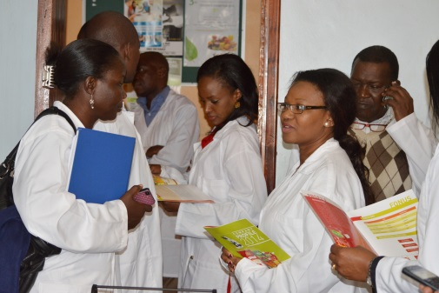 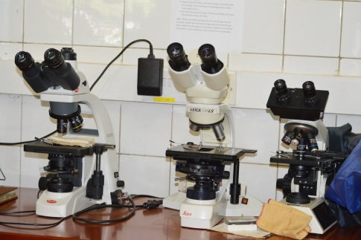

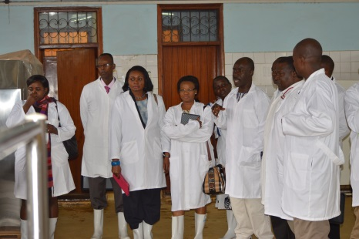 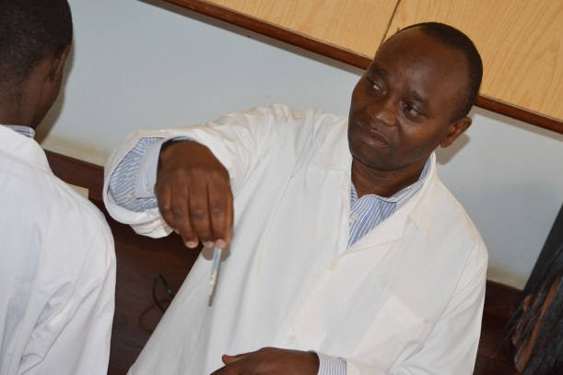

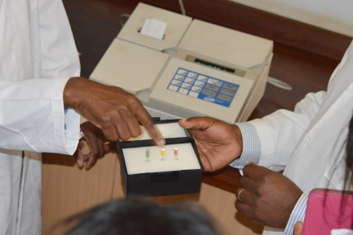 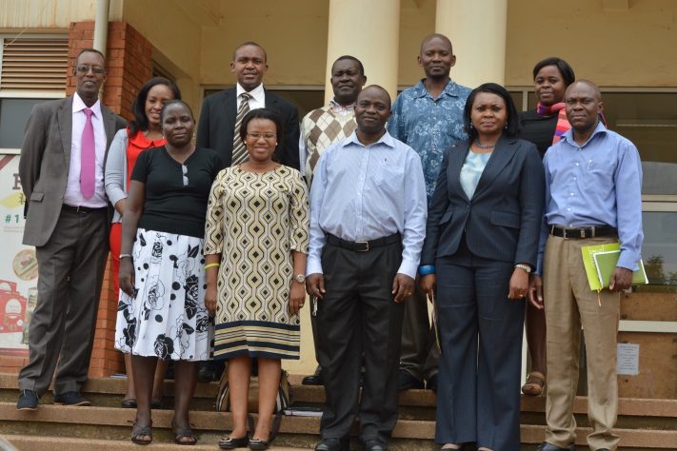

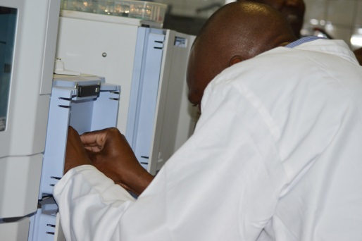 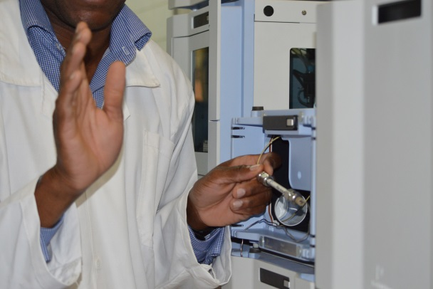 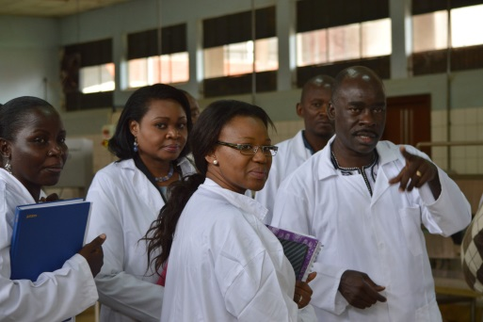

**Participants List**

|  |  |  |  |  |
| --- | --- | --- | --- | --- |
|  | Name | Organization | Position | Email |
| 1 | Mrs Kefilwe Rhoba Moalisi | NEPAD | Nutrition and food security officer | [kefilwem@nepad.org](mailto:kefilwem@nepad.org) |
| 2 | Mr. Frank Mugyenyi | AUC- Department of trade and industry | Trade expert | [MugyenyiF@africa-union.org](mailto:MugyenyiF@africa-union.org) |
| 3 | Ms. Martha Byanyima | COMESA |  |  |
| 4 | Dr. Janet Edeme | Africa Union Commission – Department of Rural Economy and Agriculture | Head of Rural Economy | [akullod@africa-union.org](mailto:akullod@africa-union.org) |
| 5 | Dr. Benoit Gnolonfin | Africa Union Commission – Department of Rural Economy and Agriculture – Partnership for Aflatoxin Control in Africa | PACA Technical Officer | [benoitg@africa-union.org](mailto:benoitg@africa-union.org) |
| 6 | Mrs. Wezi Chunga-Sambo | Africa Union Commission – Department of Rural Economy and Agriculture – Partnership for Aflatoxin Control in Africa | PACA Program Officer | [chungaw@africa-union.org](mailto:chungaw@africa-union.org); [wezichunga@hotmail.com](mailto:wezichunga@hotmail.com) |
| 7 | Dr. Joshua Mutambi | Ministry of Trade, Industry and Cooperation | Acting Commissioner, Industry and Trade | [jmutambi@yahoo.com](mailto:jmutambi@yahoo.com) |
| 8 | Maurice Opio | Ministry of Agriculture, Animal Industry and Fisheries (MAAIF) | Senior Agricultural Inspector | [mosesrafin@yahoo.co.uk](mailto:mosesrafin@yahoo.co.uk) |
| 9 | Demion Eelu | Uganda National Bureau of Standards | Trainee, Regiona Coordination Division | [eeludemy@gmail.com](mailto:eeludemy@gmail.com) |
| 10 | Norman Ojumuge | Ministry of Trade and Industry of Cooperatives | Senior Commercial officer | [nonmanojam@gmail.com](mailto:nonmanojam@gmail.com) |
| 11 | Mr. Francis Gomoro Odong | Ministry of Trade and Industry of Cooperatives | Principal Engineer |  |
| 12 | George Mwase | Ministry of Trade and Industry of Cooperatives | Deputy Director (Foreign Trade) | [georgemwase@yahoo.co.uk](mailto:georgemwase@yahoo.co.uk) |
| 13 | William Olaho Mukani | VETGOV. Regional Coordinator | EAC Secretariat, Arusha, Tanzania | [Williammolahomukani@gmail.com](mailto:Williammolahomukani@gmail.com) |
| 14 | Dr. Mabvuto Kango | Department of Social Affairs | Ag. Head – Health Nutrition and Population | [Kangom@africa-union.org](mailto:Kangom@africa-union.org) |
| 15 | Mr. Hakim Mufumbiro | Uganda National Bureau of Standards | Acting Head and Agriculture Standards Division | [hakimmufumbiro@yahoo.com](mailto:hakimmufumbiro@yahoo.com) |
| 16 | Agnes Pasky Chandia Baku | Ministry of Health | Head of Nutrition | [bakuchandia@gmail.com](mailto:bakuchandia@gmail.com) |
| 17 | Dr. Agaba Friday | National Drug Authority | Food Safety Coordinator | [agabafricay@hotmail.com](mailto:agabafricay@hotmail.com) |
| 18 | Dr. James Kakungulu | MAAIF | Principal Animal Nutritionist | [jameskakun@gmail.com](mailto:jameskakun@gmail.com) |
| 19 | Prof. Archileo Kaaya | Makerere University | Head, Department of Technology and Nutrition | [Kaaya.archileo@gmail.com](mailto:Kaaya.archileo@gmail.com) |
| 20 | Maria Bisamaza | Makerere University | Researcher | [maria.bisamaza@gmail.com](mailto:maria.bisamaza@gmail.com) |
| 21 | Mrs. Agnes Namwase | MAAIF | CAADP Focal Point |  |

1. Groups will breakout within health, trade and agriculture and discuss areas of concern using a template to guide discussions